Using the Peripherals

You can only add one peripheral at a time to the micro:bit so to make use of both you will need **two** micro:bits. Both the enviro:bit and the scroll:bit work with MakeCode but you will need to add the packages to MakeCode.

Click and then you will then get a menu, search for ‘scroll:bit’

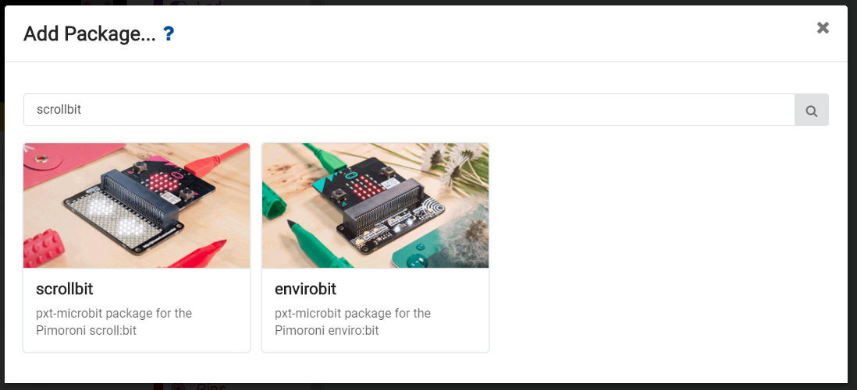

***Please note you can only add **one** package at a time, adding both packages is possible but any programs made will not work***

Once you have added a package you can access is from the blocks menu:

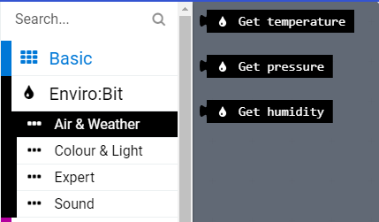

Explore these additional blocks and think about how they can be used for this project.